Aisha`s SOC Home Lab

Introduction

I built this SOC Home Lab from scratch because I wanted a space where I could safely experiment with attacks and analyze exactly what happens behind the scenes.
Security is all about hands-on experience, so I made sure to isolate this environment completely from my home network and personal devices.
This setup allows me to indulge my passion for monitoring and packet analysis in a controlled, risk-free sandbox.
For me, it's not just a project, it's where I learn how to think like both an attacker and a defender.
I am constantly evolving this lab to include more complex scenarios, simulating modern threats to refine my detection capabilities.

My Goals for This Lab
In this lab I focused on achieving several key goals to strengthen my technical skills:
- Establishing a Safe Sandbox: building a fully isolated environment where I could safely simulate threats without affecting my host machine or home network.
- Real-World Troubleshooting: I aimed to master network configurations by solving actual connectivity issues, such as the (Media Disconnected( error, which helped me understand virtual networking deeply.
- Executing Controlled Attacks: Instead of just watching tutorials, I wanted to perform the attacks myself to observe how unauthorized connections are established.
- Flexible Tool Mastery: I didn't want to limit myself to one tool. My goal was to use a variety of analysis utilities to monitor traffic and verify results from different perspectives.
- Understanding the )Why(: I focused on analyzing the raw data like the TCP Three Way Handshake to truly understand the mechanics of network communication during a breach.
- Adopting the Analyst Mindset: By playing both roles (attacker and defender), I worked on developing a balanced mindset to better detect and document suspicious activities.
Environment & Toolset
To make this lab effective I used a combination of virtualization and specialized analysis tools to monitor both the network and the system internally:
- Virtualization: Oracle VirtualBox – Used to host my Windows 11 Enterprise VM in a completely isolated environment.
- Network Analysis: Wireshark – My go-to tool for capturing traffic and inspecting the TCP handshake during the attack.
- System Monitoring:
  - Process Monitor (ProcMon): I included this to track real-time file system and Registry activity. It’s essential to see what a "malicious" script does once it runs.
  - Process Hacker: I used this for advanced process management and to monitor system resources and network connections initiated by specific processes.
- Automation: PowerShell – Used to write my own listeners and simulate the attack commands.
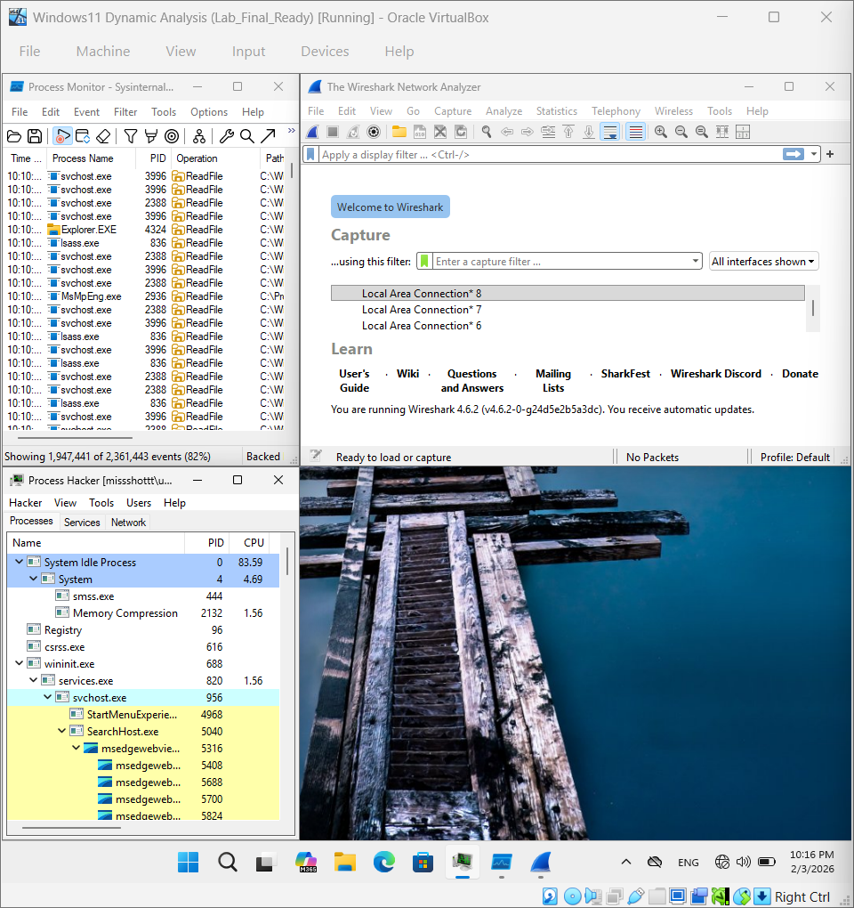

Network Isolation & Connectivity
I intentionally started with a disconnected media state to ensure a fully isolated sandbox environment, preventing any potential threats from reaching the host network.
- Isolation Phase: Verified the "Media Disconnected" status to confirm the lab's security.
- Controlled Access: Configured a local virtual adapter to assign a private IP (192.168.8.80).
- Objective: This setup allowed internal monitoring via Wireshark while maintaining total isolation from the external network.

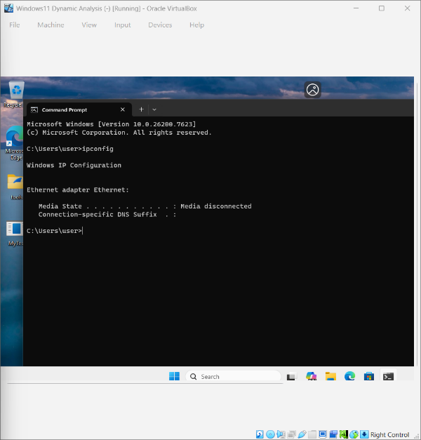
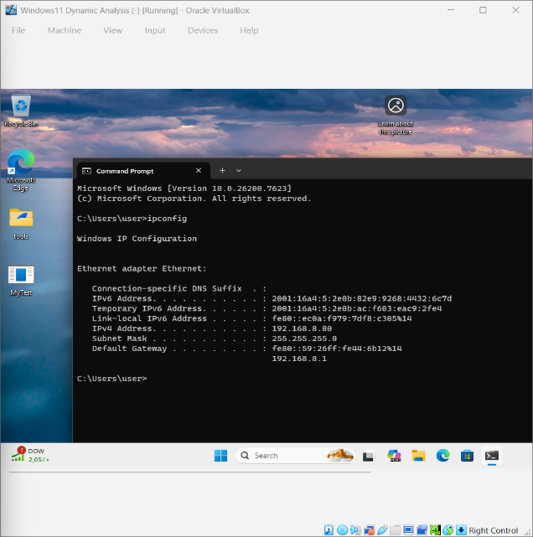

Attack Simulation & Analysis
Static Analysis & Monitoring: This shows the EICAR test code alongside ProcMon, capturing system events as the file is accessed.

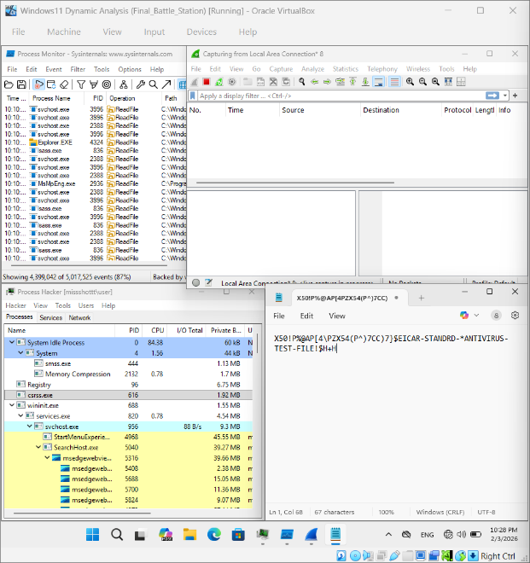
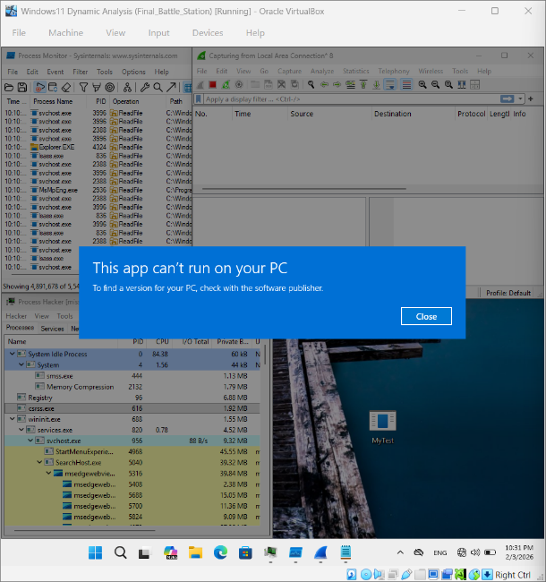

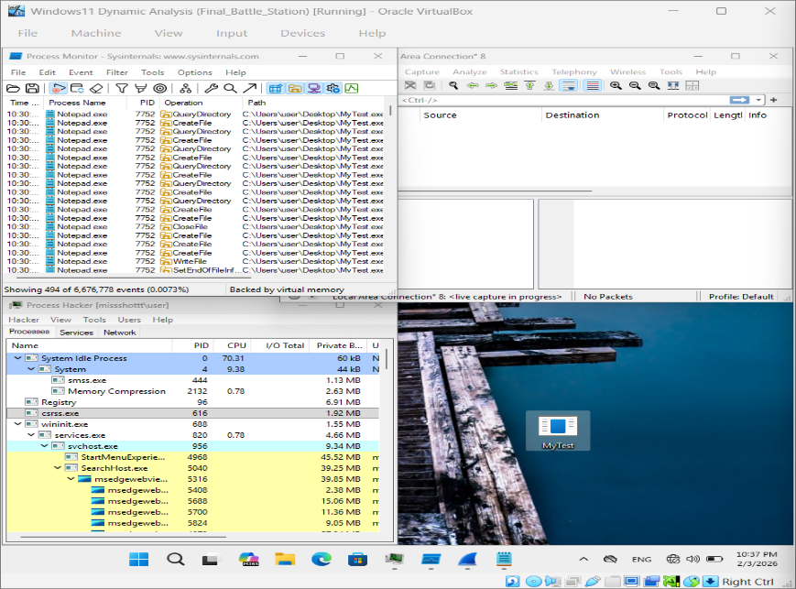

Network Traffic Analysis & Connection Simulation
Scenario Overview
To simulate a real-world unauthorized access attempt, I designed a scenario where a listener is waiting for an incoming connection on a specific port. This test evaluates the system's ability to detect and log external communication attempts.
Phase 1: The Listener & Execution
- The Listener: Using a PowerShell script inside the VM, I opened a TCP listener on Port 4444 to wait for incoming traffic.
- The Attack: From the host machine, I executed a curl command targeting the VM's internal IP (192.168.8.80:4444) to trigger a connection.
- The Result: The connection was successfully established, as confirmed by the "Connected!" status on the listener's console. 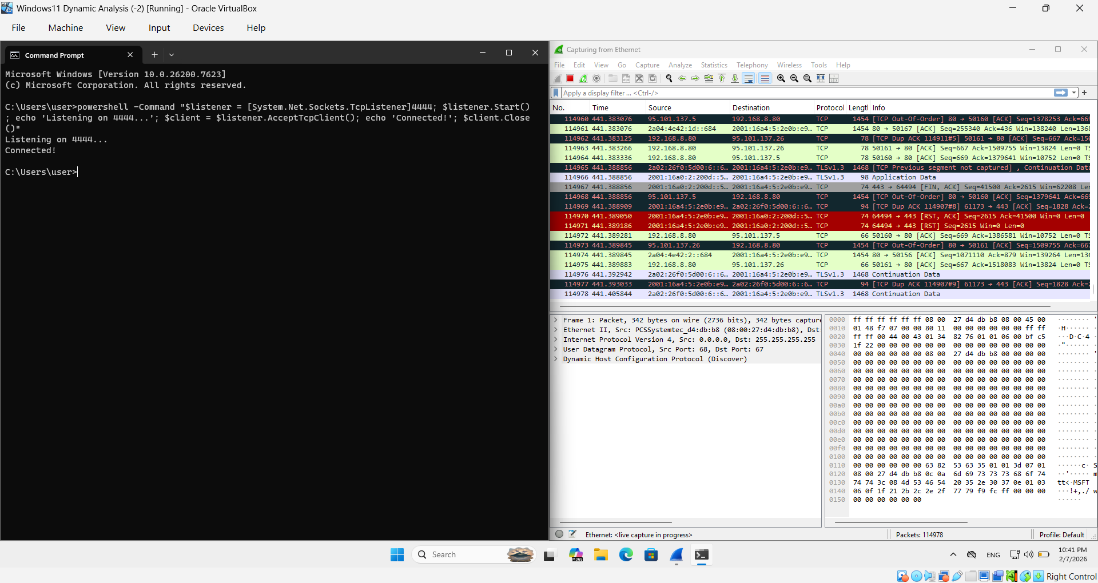

Phase 2: Deep Packet Inspection (Wireshark)
Using Wireshark, I monitored the network interface to capture and analyze the raw data exchange during the simulation:
- Traffic Filtering: I applied the display filter tcp.port == 4444 to isolate the relevant packets from background network noise.
- Handshake Analysis: I successfully identified the TCP Three-Way Handshake (SYN, SYN-ACK, ACK) between the host and the VM, confirming a valid session setup.
- Monitoring Outcome: The capture provided clear evidence of the connection timeline, proving that all unauthorized attempts are logged and can be audited.
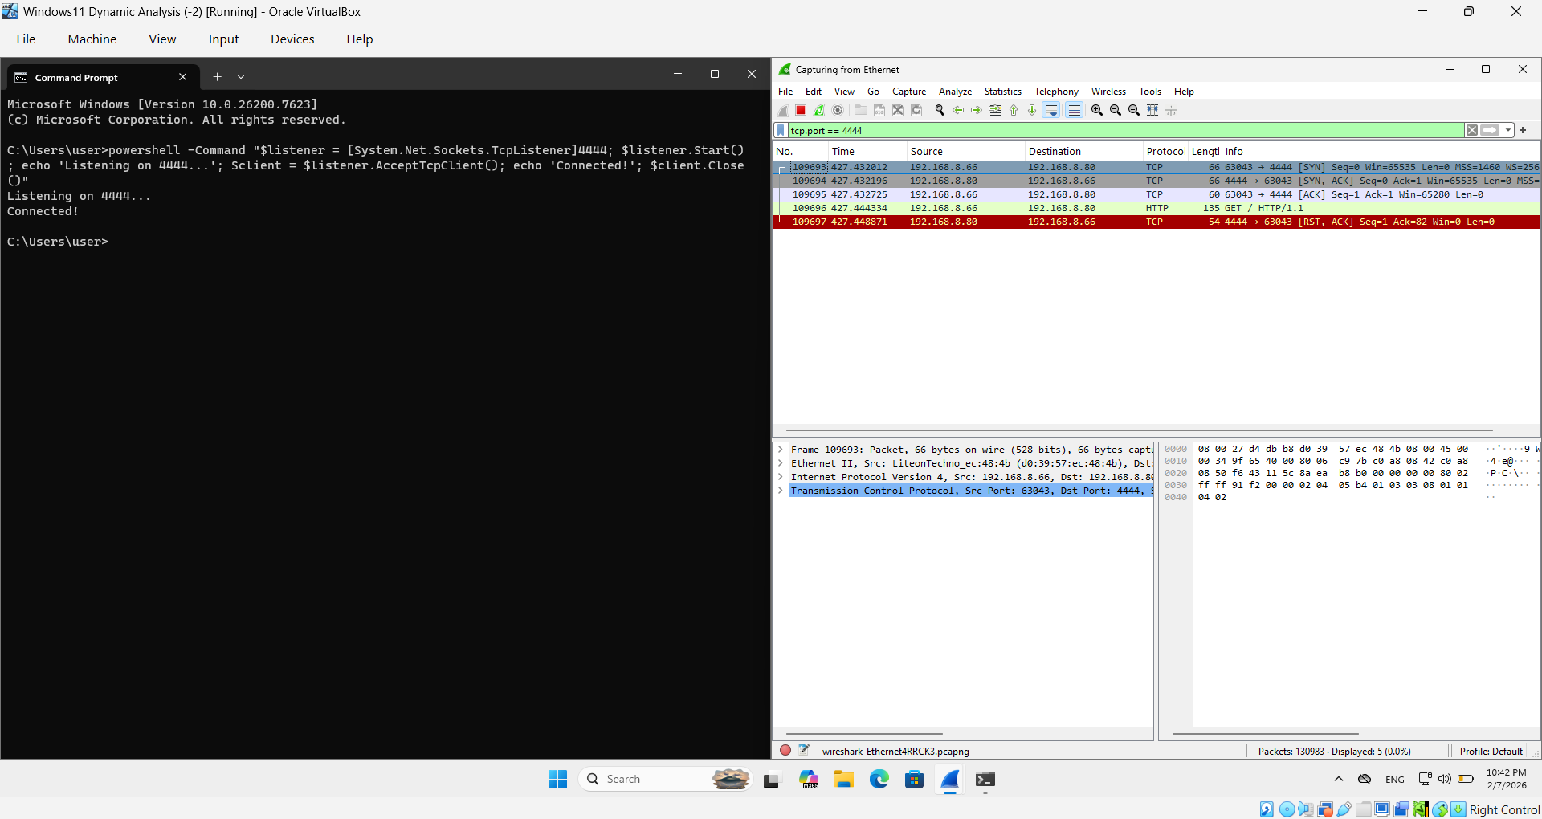
Conclusion
This project successfully demonstrated the implementation of a controlled SOC Analyst Lab for malware analysis and network forensics. By establishing a strictly isolated environment, I was able to safely execute suspicious files and simulate unauthorized network connections without risking the host system's integrity.
Key Technical Achievements:
- Environment Security: Successfully configured network isolation to prevent malware "leaking" while maintaining internal connectivity for analysis.
- Behavioral Analysis: Utilized ProcMon and Process Hacker to track real-time system changes, registry modifications, and process-level interactions.
- Network Forensics: Demonstrated expertise in packet analysis using Wireshark, specifically identifying the TCP Three-Way Handshake and filtering malicious traffic.
This lab serves as a foundational platform for ongoing cybersecurity research, incident response training, and the continuous monitoring of evolving digital threats.

